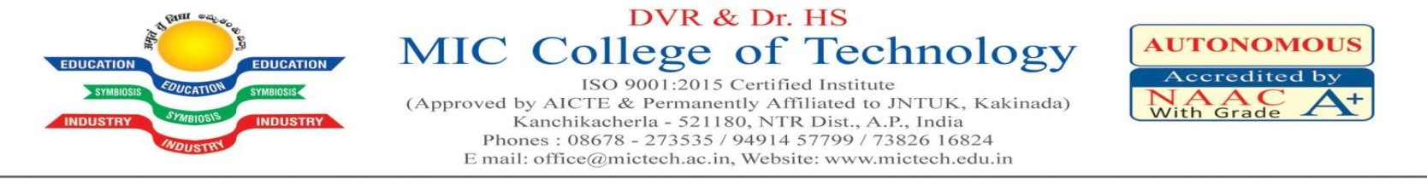
LESSON PLAN

IIl B.TECH V SEM
SUBJECT NAME: COMMUNICATION SKILLS FACULTY: B.SWETHA KRUSHI

S.NO  UNIT/ TOPIC NO. | TOPIC NAME | NO. OF CLASSES REQUIRED
1 | SELF INTRODUCTION | 1
2 | SELF INTRODUCTION | 1
3 | SELF INTRODUCTION | 1
4 | QUESTIONS RELATED TO PERSONAL INTERVIEW(HR ROUND) | 1
5 | QUESTIONS RELATED TO PERSONAL INTERVIEW(HR ROUND) | 1
6 | QUESTIONS RELATED TO PERSONAL INTERVIEW(HR ROUND) | 1
7 | COLLABORATION SKILLS | 1
8 | COLLABORATION SKILLS | 1
9 | PROFESSIONAL ETIQUETTE | 1
10 | CAREER ORIENTATION | 1
11 | CAREER ORIENTATION | 1
12 | TEAM WORK | 1
13 | LEADERSHIP STRATEGIES | 1
14 | LEADERSHIP STRATEGIES | 1
15 | TIME MANAGEMENT SKILLS | 1
16 | POSITIVE THINKING | 1
Total number of hours : |  | 16

FACULTY HOD

